

Year 8 Science
Task 10: Physics 1 Test 2019 Name:______

SECTION 1: MULTIPLE CHOICE (1 mark each)
Circle your answer on the multiple choice answer sheet.

- Which is the best definition of energy?

  - A measure of the ability to do work.
  - A measure of the motion of an object.
  - A measure of the temperature of something.
  - A measure of the amount of matter in an object.

- An object that is sitting still on the top of a hill has

  - a lot of potential energy and not much kinetic energy.
  - a lot of kinetic energy and not much potential energy.
  - a lot of kinetic and potential energy.
  - not much kinetic or potential energy.

- Energy is measured in

  - metres (m)
  - Newtons (N)
  - Joules (J)
  - Watts (W)

- Which of these is not a type of energy?

  - elastic
  - light
  - heat
  - pushing

- Which type of energy is contained in food?

  - mechanical
  - chemical
  - solar
  - nuclear

- Which of these is not a sustainable or renewable energy source?

  - solar panels
  - wind turbines
  - diesel generator
  - wave generator

- The original source of all energy on Earth is

  - the sun.
  - plants.
  - fossil fuels.
  - food.

- A hair dryer works by which of the following energy transfers and transformations?

  - Electrical energy is converted to heat energy and kinetic energy.
  - Heat energy is converted to electrical energy and kinetic energy.
  - Kinetic energy is converted to heat energy and electrical energy.
  - Heat energy and kinetic energy are converted to electrical energy.

- In a light bulb, the useful energy output is

  - sound.
  - heat.
  - light.
  - electric.

- Which of the following best describes the energy transformation within a microphone?

  - Kinetic energy is converted to sound energy.
  - Kinetic energy is converted to potential energy.
  - Electrical energy is converted to kinetic energy.
  - Kinetic energy is converted to electrical energy.

- If we tighten strings of instrument pitch will be
- Higher
- Lower
- Constant
- No pitch

- As compared to air, sound travels fastest in
- Liquids
- gases
- vacuum
- solid
  - In concert halls, soft materials and carpets are used to
- increase sound waves
- absorb sound waves
- increase speed of sound waves
- refract sound waves

  - Change in a direction or bending of light when it is travelling from one transparent medium to another medium is called
- reflection
- refraction
- transmission
- incident
  - A region of darkness which is formed when path of light is blocked is called
    - shadow
    - opaque image
    - inverted picture
    - pinhole

  - A spinning disc of rainbow colours will produce
a) multi shape spin
b) white light
c) dispersed light
d) red light
  - A mirror that produces a regular reflection is called
- a plane mirror
- a convex mirror
- a concave mirror
- none of the above

  - Refraction is the
- Bouncing back of light
- Absorbtion of light
- Visible spectrum of light
- The bending of light

  - Which of these is not a method of heat transfer?

  - convection
  - conduction
  - radiation
  - insulation

  - Which of the following is the most effective heat insulator?

- metal
- wood
- air
- a vacuum

  - A material which easily allows heat to move through it is called

- an insulator.
- a conductor.
- a resistor.
- a circuit.

  - When heat radiation hits a transparent surface such as glass, it may travel straight through, as shown in the diagram below.
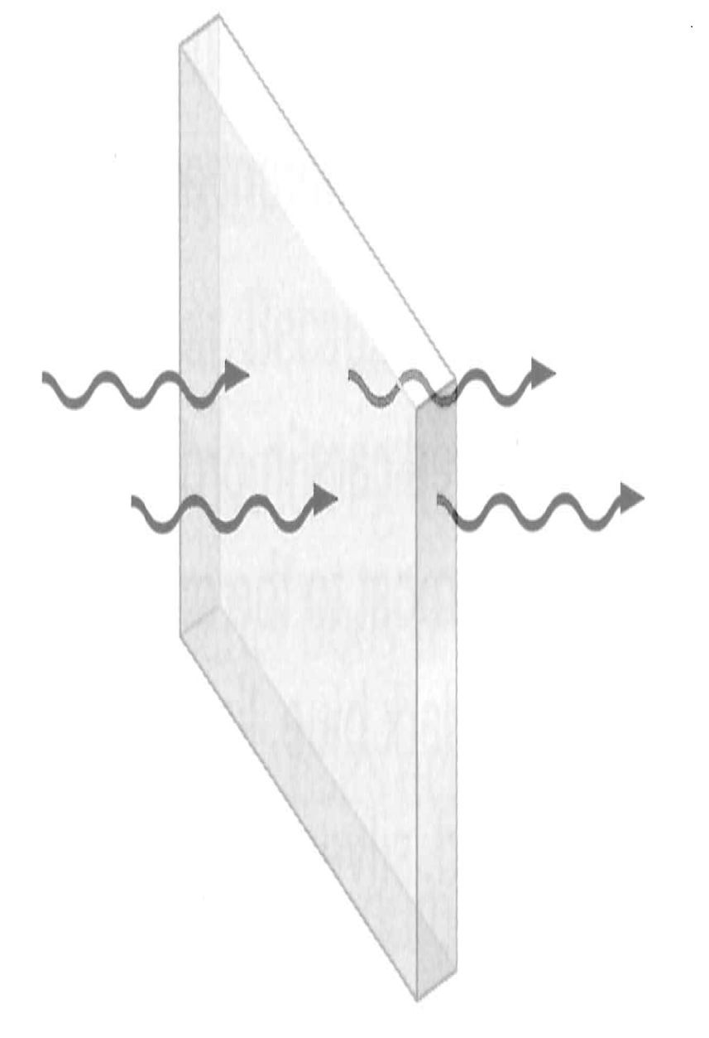
This is called
- transmission
- reflection
- absorption
- refraction

    - Which type of surface tends to be a good heat absorber?

- dull and dark
- shiny and light
- sparkly and colourful
- transparent

    - Most of the heat energy lost from a house in winter is lost through the

- floor.
- roof.
- windows.
- doors.

- The Coolgardie safe was invented during the 1890s gold rush to keep store cold food. It cools because of

- insulation.
- radiation.
- evaporation.
- Conduction

SECTION 2: WRITTEN
Write your answers in the spaces on the answer sheet provided.

- Classify each of these energy types as energy in action or potential (5)
- chemical
- elastic
- gravitational
- heat
- sound

- Using the types of energy from question 1 copy and complete the correct types of energy below (9)

Appliance | Input Energy | Source | Output Energy | Receiver
electric toaster | (a) | power point | (b) | (c)
solar hot water system | (d) | (e) | heat | (f)
petrol engine | chemical | (g) | (h) | (i)

Appliance | Input Energy | Source | Output Energy | Receiver
electric toaster |  | power point
solar hot water system |  |  | heat
petrol engine | chemical

- State one problem that is associated with using fossil fuels (1)

- A hot water system is 65% efficient. If it is supplied with 1000 Joules of energy, how much heat energy will it produce? (2)

- Draw an energy flow diagram to represent the coal fired power station shown in the diagram below (4)

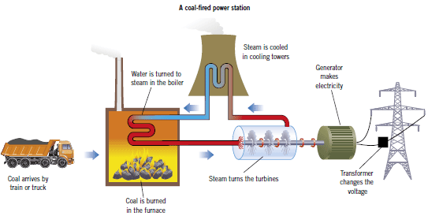

- The diagram below shows conduction, convection and radiation.
Use these diagrams to explain how heat travels by each method.(3)
How well do each of these occur in solids, liquids, gases and space. (6) Answer on the next page

Heat Transfer | Explain | Made up of solid, liquid or gas
Conduction |  | power point
Convection
Radiation

END OF TEST (OUT OF 55 MARKS)

